**Rising demand of battery-powered vehicles for sustainable environment of Bangladesh: A review of challenges and opportunities in Bangladesh**

**1. Introduction**

Nowadays Electric Vehicles (EVs) are making a significant contribution to our daily lives these days. These Electric Vehicles (EVs) make our life so easy and comfortable. EVs were first introduced in the mid-19th century. For almost 100 years, the modern internal combustion engine has been dominated by motor vehicles. In the 21st century, technological developments focused on renewable energy. As a result, the demand for electric vehicles was increasing a lot at that time, and this demand is increasing day by day. The global share of electric vehicles was just about 2% in 2016, which is expected to increase to 22% in the year 2030 [1]. For the first time in 2017, more than a million new electric vehicle cars (EVs) were sold around the world. The number of new Electric Vehicles (EVs) sold was about 4.5 million units in 2020. In 2025, the annual passenger Electric Vehicle (EV) sales are expected to reach 10 million. In 2030, it will grow to about 28 million and 56 million by the year 2050. The world’s largest electric car market is the Chinese market, which sold about 1.1 million electric cars in 2018. It expanded the selling amount by about 72 percent by the year 2017. At the end of 2018, there were about 1.2 million electric cars in Europe and 1.1 million electric cars in the United States of America on the road. From 2017, the market growth of electric cars grew up to 385,000 and 361,000. In 2018, the highest electric car market share was about 46% of its new electric car sales in Norway. The second largest electric car market share was 17% in Iceland, and it was almost six times higher than in Norway and Sweden at 8%. By the end of 2018, the big amount of electric two/three-wheelers on the road was about 300 million. Most of these electric cars are in China. About 10 million sales in China per year. There were about 5 million units of low-speed electric vehicles (LSEVs) in 2018. Which was greater than the amount of the previous year, and the amount was 4.3 million. All these low-speed electric vehicles (LSEVs) were in China.

The global electric car sales are growing rapidly between 2020 and 2025. About 17 million electric vehicles were sold in 2024, which captures more than 20% of new passenger car sales worldwide. These changes affect the selling of electric vehicles and encourage the people to buy EVs. Even after the pandemic situation, these electric vehicles’ selling ratio is growing enormously. Buyers are interested in this nowadays. Falling battery costs: many manufacturing companies launch battery-powered electric vehicles [2]. Consumer adoption and companies’ production are being accelerated. The global EV fleet and annual sales both are rising rapidly. In 2025 the growth is increasingly rising. China is continuously increasing the sales volume and dominating the other countries. The registrations remain strong in Europe. The sales will rise to 20 million in the year 2025. China meets the global domestic demand by falling vehicle prices. Europe is strict with the emission regulations and rising the adoption of electric vehicles. The U.S. is growing slowly with the latest trend of EVs to mitigate the carbon footprint. The demand for electric batteries and supply infrastructure has been expanded on a large scale. The demand for energy of EV-related batteries rose to nearly 1 terawatt-hour (TWh), with the large amount of demand (over 85%) and the growth also visible with the large electric vehicles such as electric trucks or buses [3]. Manufacturing factories like battery cell factories, charging stations, and electricity supplier factories are also growing aggressively. China continues to increase its battery cell production in the global market. The United States, India, and Indonesia are also enhancing the global capacity. These enlargements will help to reduce further costs of electric vehicles and the cost of batteries, and they will help to integrate the vertical supply chain. However, this transition has not been visible for many reasons. People’s affordability is the major barrier to owning an electric vehicle. For this the adoption rate is slowly growing. But China makes many cheaper models for the people who are willing to adopt an electric vehicle. Electric Vehicles (EVs) are still not affordable for the people in many countries like Germany or the United States. The price of EVs in these countries is much higher for the general people to adopt this. Besides, there are many countries where EVs are not so available and the adoption rate of electric vehicles is much less. Charging infrastructure is also the major barrier for the adoption of electric vehicles. Additionally, there are some grid integration issues like peak demand, charging time, load management, etc. And we must consider the battery lifecycle concerns like battery recycling, material supply, and environmental impacts of mining. In mid-2025, the projection suggested the continuous growth of sales of electric vehicles (EVs). The IEA’s Global EV Outlook 2025 forecasts that EV sales will reach 20 million units in 2025. The EVs will make up 25% of new car sales globally in the world market [4]. This trend is rising continuously, but it depends on some conditions (reduction of battery costs, expansion of charging infrastructure, and tighter emission policy systems in becoming automotive regions like the European Union (EU), China, and some parts of Asia). This will help to improve the supply chain of electric vehicles (EVs) in global markets.

In Asia, the electric vehicle industry is new to this continent. The electric vehicle industry and the EV acceptance for the people are at the early stage. The EV adoption rate is less than 1 percent, and many vehicle manufacturer companies are just starting to launch EV models. In Bangladesh the government rolled out some tax policies for the people to encourage the EV adoption. But there is a big barrier to charging infrastructure that is not established in our country. Since the carbon dioxide emissions level is growing high and the environment is polluting severely. There need to be acknowledged renewable-energy sources like Electric Vehicles (EVs), which will help to decrease the Greenhouse Gas (GHG) emission levels.

Source:

[https://pdfs.semanticscholar.org/5ae2/6c9 316455f2fcb1a291b4f14271674ba6633.pdf](https://pdfs.semanticscholar.org/5ae2/6c9%20316455f2fcb1a291b4f14271674ba6633.pdf)

[https://about.bnef.com/insights/clean-energy/battery-pack-prices-fall-to-an-average-of-132-kwh-but-rising-commodity-prices-start-to-bite/](https://about.bnef.com/insights/clean-energy/battery-pack-prices-fall-to-an-average-of-132-kwh-but-rising-commodity-prices-start-to-bite/?utm_source=chatgpt.com)<https://www.iea.org/reports/global-ev-outlook-2025/electric-vehicle-batteries>

[https://www.iea.org/reports/global-ev-outlook-2025/executive-summary](https://www.iea.org/reports/global-ev-outlook-2025/executive-summary?utm_source=chatgpt.com)

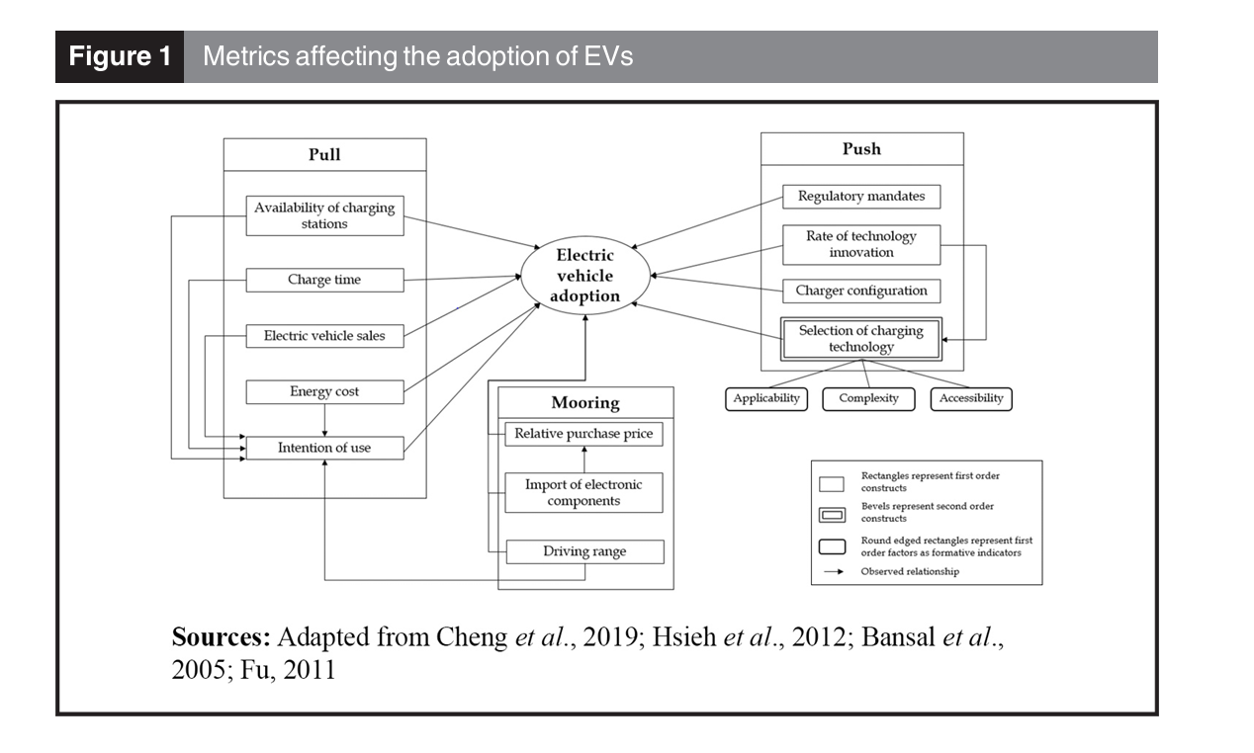

**2. Review Methodology (Nehal)**

Literature sources

Time span

Selection criteria

Screening

Contribution

**3. Recent Research Trends and Saturation Analysis (shakil)**

Number of Publications

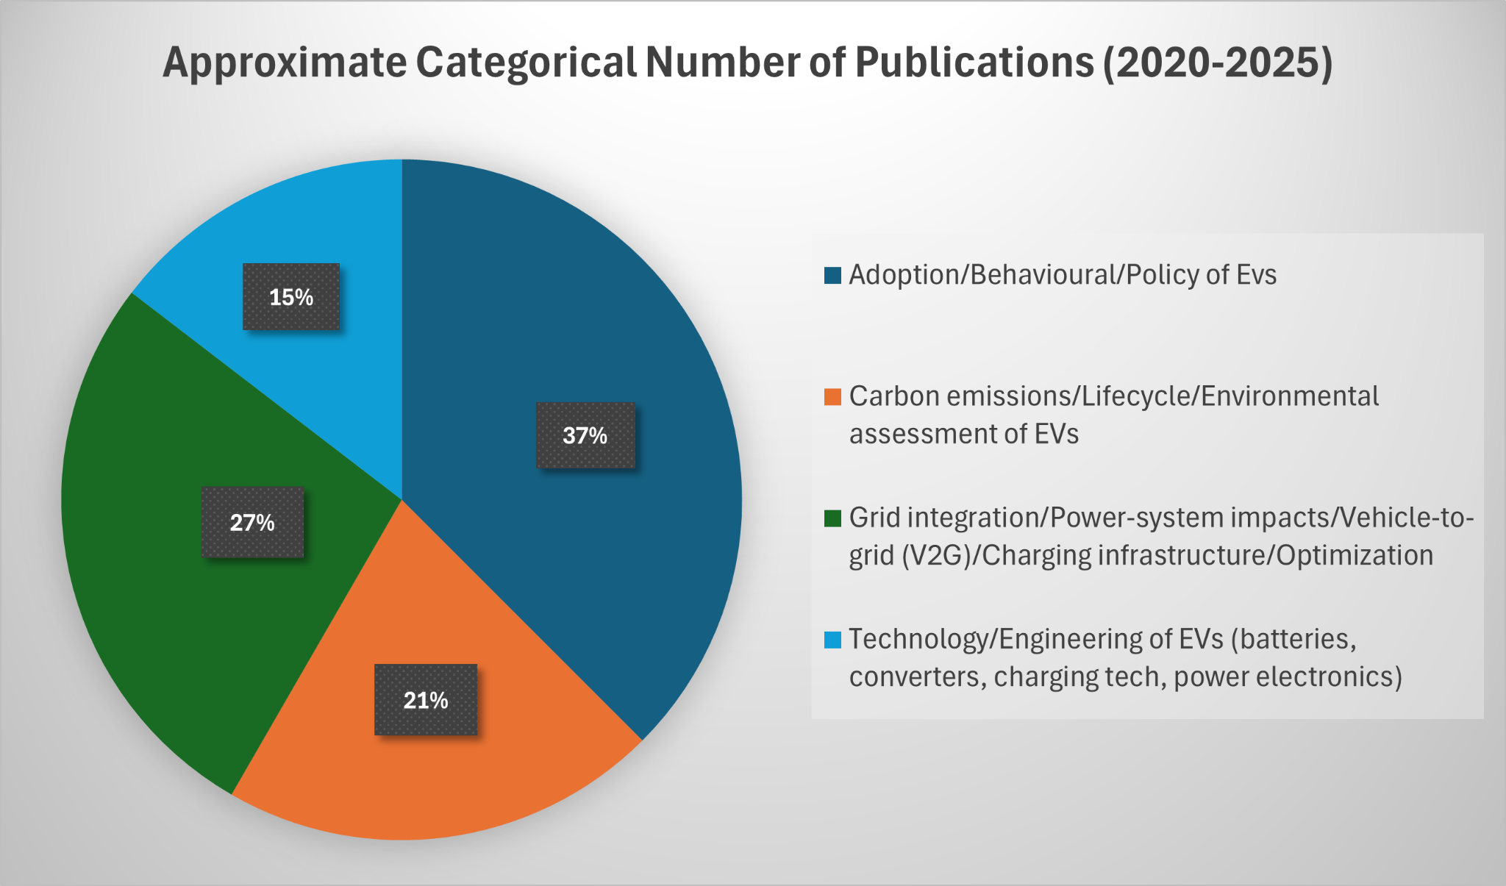

In this pie chart, it shows the approximate categorical number of publications from 2020 to 2025. We divided the publications into four types. The first category is adoption/behavioral/policy of electric vehicles (EVs). The carbon emission/lifecycle/environmental assessment of EVs is the second category. The third category is about grid integration/power system impacts/vehicle-to-grid (V2G)/charging infrastructure/charging optimization. And the last category is involved with the EV technology/engineering of EVs (battery converters, charging technology, and power electronics). From this pie chart we can easily see that the maximum percentage is in the first category, and this is about 37%. About 27% are in the third category, which is the second highest categorical number of publications. There is about 21% in the third category. The lowest percentage of the approximate categorical number of publications is about 15% in the fourth category. Besides these, there are many publications of various categories. But we choose these four types of categories to clarify the most common fields of publications on electric vehicles (EVs).

Source:

[https://www.mdpi.com/2032-6653/15/8/375](https://www.mdpi.com/2032-6653/15/8/375?utm_source=chatgpt.com#B1-wevj-15-00375)

[https://www.mdpi.com/1996-1073/17/22/5667](https://www.mdpi.com/1996-1073/17/22/5667?utm_source=chatgpt.com)

[https://energyinformatics.springeropen.com/articles/10.1186/s42162-022-00251-2](https://energyinformatics.springeropen.com/articles/10.1186/s42162-022-00251-2?utm_source=chatgpt.com)

[https://link.springer.com/article/10.1007/s42452-025-06996-1](https://link.springer.com/article/10.1007/s42452-025-06996-1?utm_source=chatgpt.com)

[https://www.mdpi.com/2076-3417/14/18/8197](https://www.mdpi.com/2076-3417/14/18/8197?utm_source=chatgpt.com)

[https://www.mdpi.com/1996-1073/17/15/3786](https://www.mdpi.com/1996-1073/17/15/3786?utm_source=chatgpt.com)

[https://link.springer.com/article/10.1007/s43621-025-01683-y](https://link.springer.com/article/10.1007/s43621-025-01683-y?utm_source=chatgpt.com)

[https://ouci.dntb.gov.ua/en/works/7PPn0BQ7/](https://ouci.dntb.gov.ua/en/works/7PPn0BQ7/?utm_source=chatgpt.com)

[https://energyinformatics.springeropen.com/articles/10.1186/s42162-024-00379-3](https://energyinformatics.springeropen.com/articles/10.1186/s42162-024-00379-3?utm_source=chatgpt.com)

[https://www.sdewes.org/jsdewes/pid13.0568](https://www.sdewes.org/jsdewes/pid13.0568?utm_source=chatgpt.com)

<https://www.opastpublishers.com/open-access-articles/review-of-electric-vehicletogrid-v2g-technology-8431.html>

[https://www.maxapress.com/article/id/67150246fa6c58164d6d4b1c](https://www.maxapress.com/article/id/67150246fa6c58164d6d4b1c?utm_source=chatgpt.com)

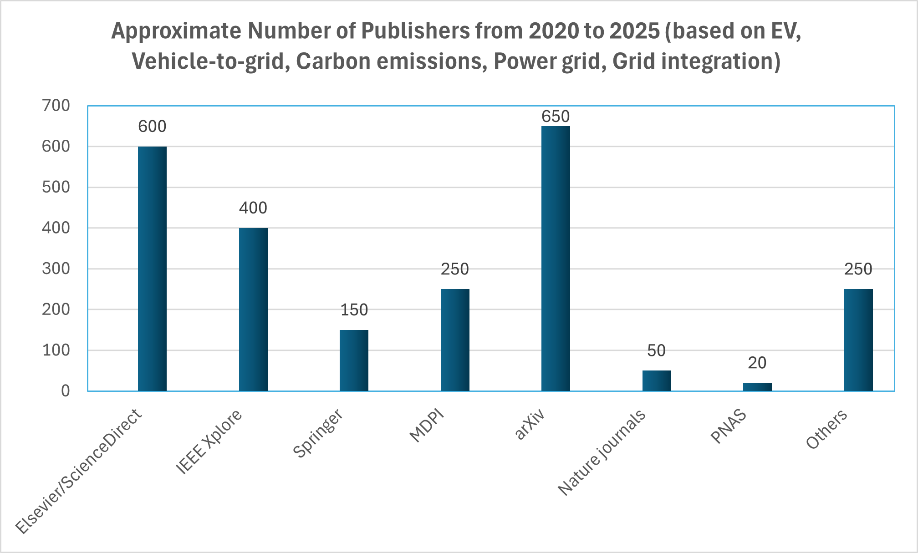

In the recent trend of electric vehicles (EVs), there are many publications published in many journals. But in this section, we discuss the approximate number of publishers from 2020 to 2025 based on EV, vehicle-to-grid, carbon emissions, power grid, and grid integration. The most publications are from the arXiv publisher, and this amount is about 650. The second highest number of publications published by the Elsevier/ScienceDirect journal is almost 600. IEEE Xplore also has a good contribution of publications. IEEE Xplore journal published about 400 papers in these fields. Approximately 250 publications are published by the MDPI journal. Springer published almost 150 publications in these fields. In Nature journals the number of these publications published is low, and this is about 50 publications. In this figure we can see the lowest number of publications published by the PNAS journal. The number of publications in the PNAS journal is only 20. Besides these journals there are many articles that are published in various journals that are related to these fields. The percentage of this trend is increasingly growing day by day. The other journals published almost 250 publications in these fields. This figure shows us the approximate number of publications published by many types of journals.

Source:

<https://www.sciencedirect.com/science/article/pii/S2590174524003428>

[https://link.springer.com/article/10.1007/s44282-025-00201-9](https://link.springer.com/article/10.1007/s44282-025-00201-9?utm_source=chatgpt.com)

[https://www.mdpi.com/1996-1073/17/22/5667](https://www.mdpi.com/1996-1073/17/22/5667?utm_source=chatgpt.com)

[https://arxiv.org/html/2507.17277v1](https://arxiv.org/html/2507.17277v1?utm_source=chatgpt.com)

[https://www.nature.com/articles/s41467-023-42893-0](https://www.nature.com/articles/s41467-023-42893-0?utm_source=chatgpt.com)

[https://www.sciencedirect.com/science/article/abs/pii/S1361920925001142](https://www.sciencedirect.com/science/article/abs/pii/S1361920925001142?utm_source=chatgpt.com)

[https://www.sciencedirect.com/science/article/pii/S2211467X25001191](https://www.sciencedirect.com/science/article/pii/S2211467X25001191?utm_source=chatgpt.com)

Research Summary

**4. Current Scenario of Battery-Powered Vehicles (shakil)**

**Growth trends**

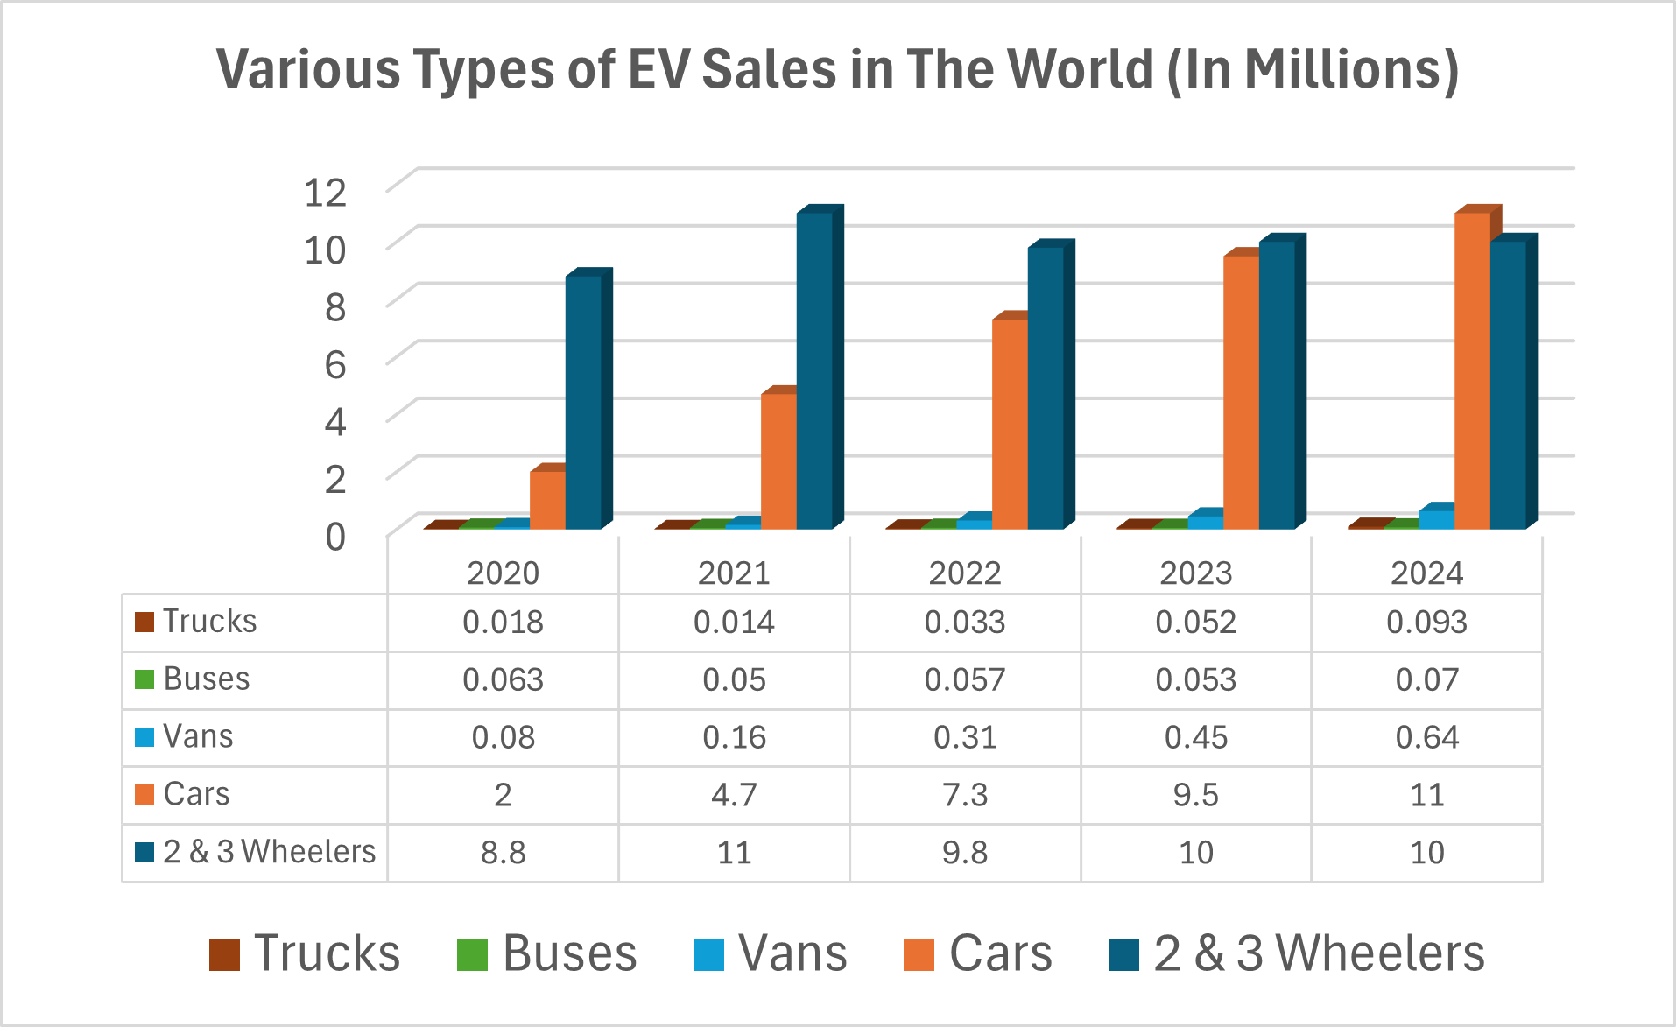

Source:

<https://www.iea.org/data-and-statistics/data-tools/global-ev-data-explorer>

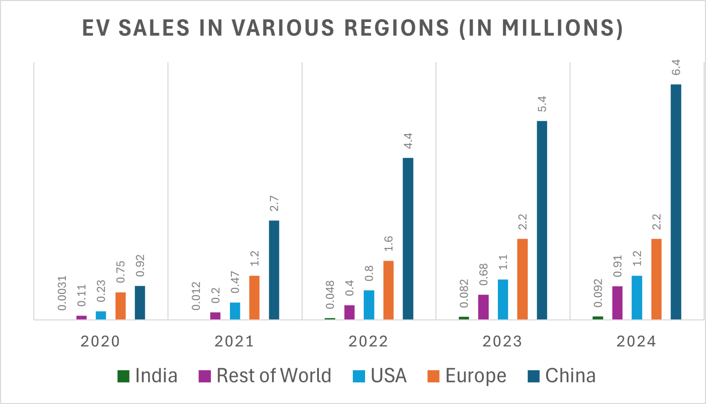

In this bar chart, it depicts the EV sales in various regions from 2020 to 2024. The regions are divided into five parts: India, the USA, Europe, China, and the rest of the world. In 2020, the EV sales were about 0.92 million in China, 0.75 million in Europe, 0.0031 million in India, 0.23 million in the USA, and 0.11 million in the rest of the world. In 2021 the number of EV sales slightly increased. About 2.7 million in China, 1.2 million in Europe, 0.012 million in India, 0.47 million in the USA, and 0.2 million in EV sales in 2021. There were about 4.4 million, 1.6 million, 0.048 million, 0.8 million, and 0.4 million EV sales, respectively, in China, Europe, India, the USA, and the rest of the world in 2022. In the next year we can see that EV sales were increasing fast compared to the previous year in all regions. In 2023, EV sales were about 5.4 million, 2.2 million, 0.082 million, 1.1 million, and 0.68 million, respectively, in China, Europe, India, the USA, and the rest of the world. In the last year of this bar chart, 2024, EV sales were about 6.4 million in China, 2.2 million in Europe, 0.092 million in India, 1.2 million in the USA, and 0.91 million in the rest of the world. From this chart we can easily see that the most EV sales were in China. The second-highest EV sales were in Europe, and the lowest EV sales were in India. But we can find the growth of EV sales is increasing day by day. The demand for this EV is rapidly growing by people of the world.

Source: <https://www.iea.org/data-and-statistics/data-tools/global-ev-data-explorer>

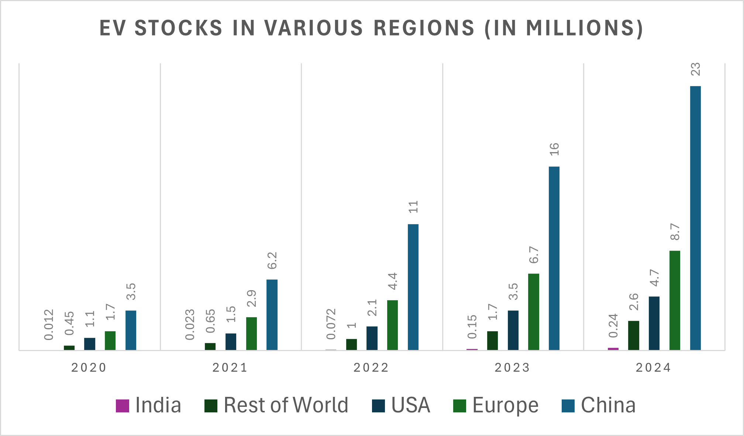

This bar chart depicts the EV stocks in various regions from 2020 to 2024. The regions are divided into five parts: India, the USA, Europe, China, and the rest of the world. In 2020, the EV stocks were about 3.5 million in China, 1.7 million in Europe, 0.012 million in India, 1.1 million in the USA, and 0.45 million in the rest of the world. In 2021 the number of EV stocks slightly increased. About 6.2 million in China, 2.9 million in Europe, 0.023 million in India, 1.5 million in the USA, and 0.65 million of EV stocks in 2021. About 11 million, 4.4 million, 0.072 million, 2.1 million, and 1 million EV stocks, respectively, in China, Europe, India, the USA, and the rest of the world in 2022. In the next year we can see that EV stocks increased fast compared to the previous year in all regions. In 2023, EV stocks were about 16 million, 6.7 million, 0.15 million, 3.5 million, and 1.7 million, respectively, in China, Europe, India, the USA, and the rest of the world. In the last year of this bar chart, 2024, EV stocks were about 23 million in China, 8.7 million in Europe, 0.24 million in India, 4.7 million in the USA, and 2.6 million in the rest of the world. From this chart we can easily compare the most EV stocks in China. The second-highest EV stocks in Europe and the lowest EV stocks in India. But we can find the growth of EV stocks is increasing day by day. The demand for this EV is rapidly growing among people of the world.

Source: <https://www.iea.org/data-and-statistics/data-tools/global-ev-data-explorer>

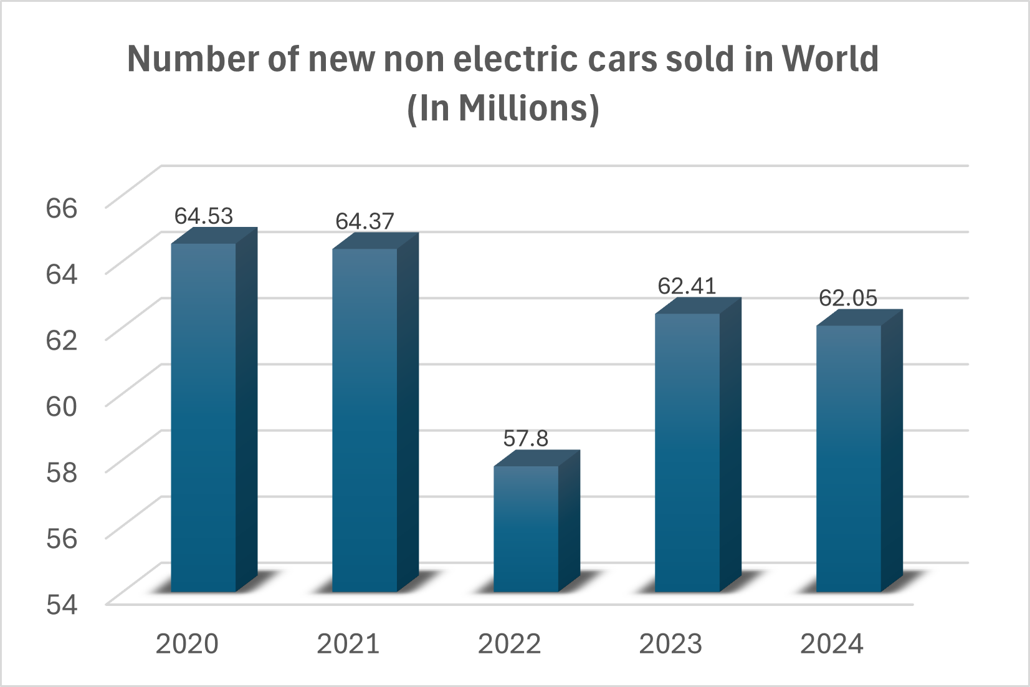

Source: <https://ourworldindata.org/grapher/car-sales>

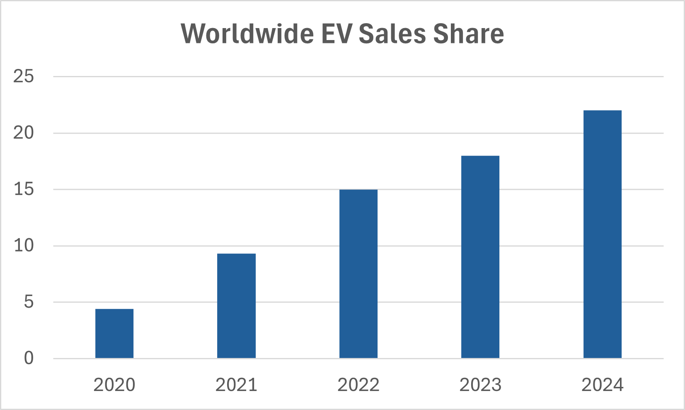

In this bar chart, we can see that the worldwide EV sales share is increasing day by day. In 2020, the EV sales share was only about 4.4% all over the world. The number of these sales shares almost doubled in the next year, and it was about 9.3%. In 2022, the EV sales share increased slightly. There were about 15% of sales shares of EVs in 2022. In 2023 and 2024, the EV sales share was increasing at a promising rate. Almost 18% of EV sales shares were in 2023, and about 22% of EV sales shares were in 2024 worldwide.

Source: <https://www.iea.org/data-and-statistics/data-tools/global-ev-data-explorer>

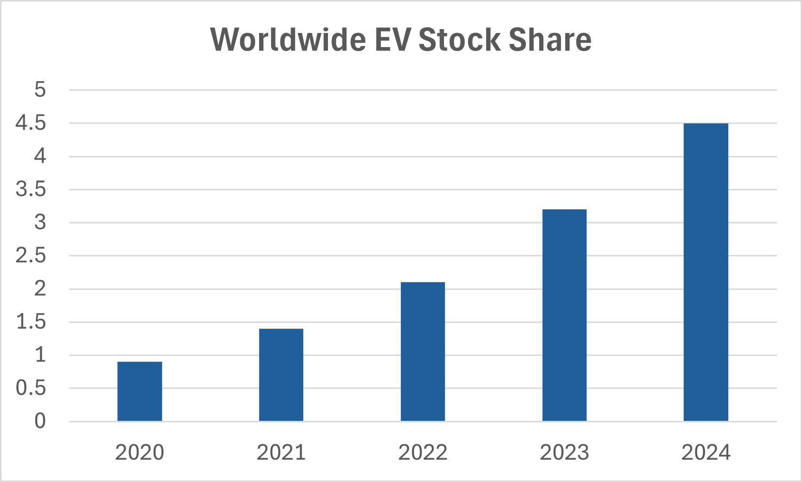

From this bar chart, we can see that the worldwide EV stock share is increasing day by day. In 2020, the EV stock share was only about 0.9% all over the world. The amount of this stock share almost doubled in the next year, and it was about 1.4%. In 2022, the EV stock share increased slightly. There were about 2.1% stock shares of EVs in 2022. In 2023 and 2024, the EV stock shares were increasing at a promising rate. Almost 3.2% of EV stock shares were in 2023, and about 4.5% of EV stock shares were in 2024 worldwide.

Source: <https://www.iea.org/data-and-statistics/data-tools/global-ev-data-explorer>

**Regional overview:**

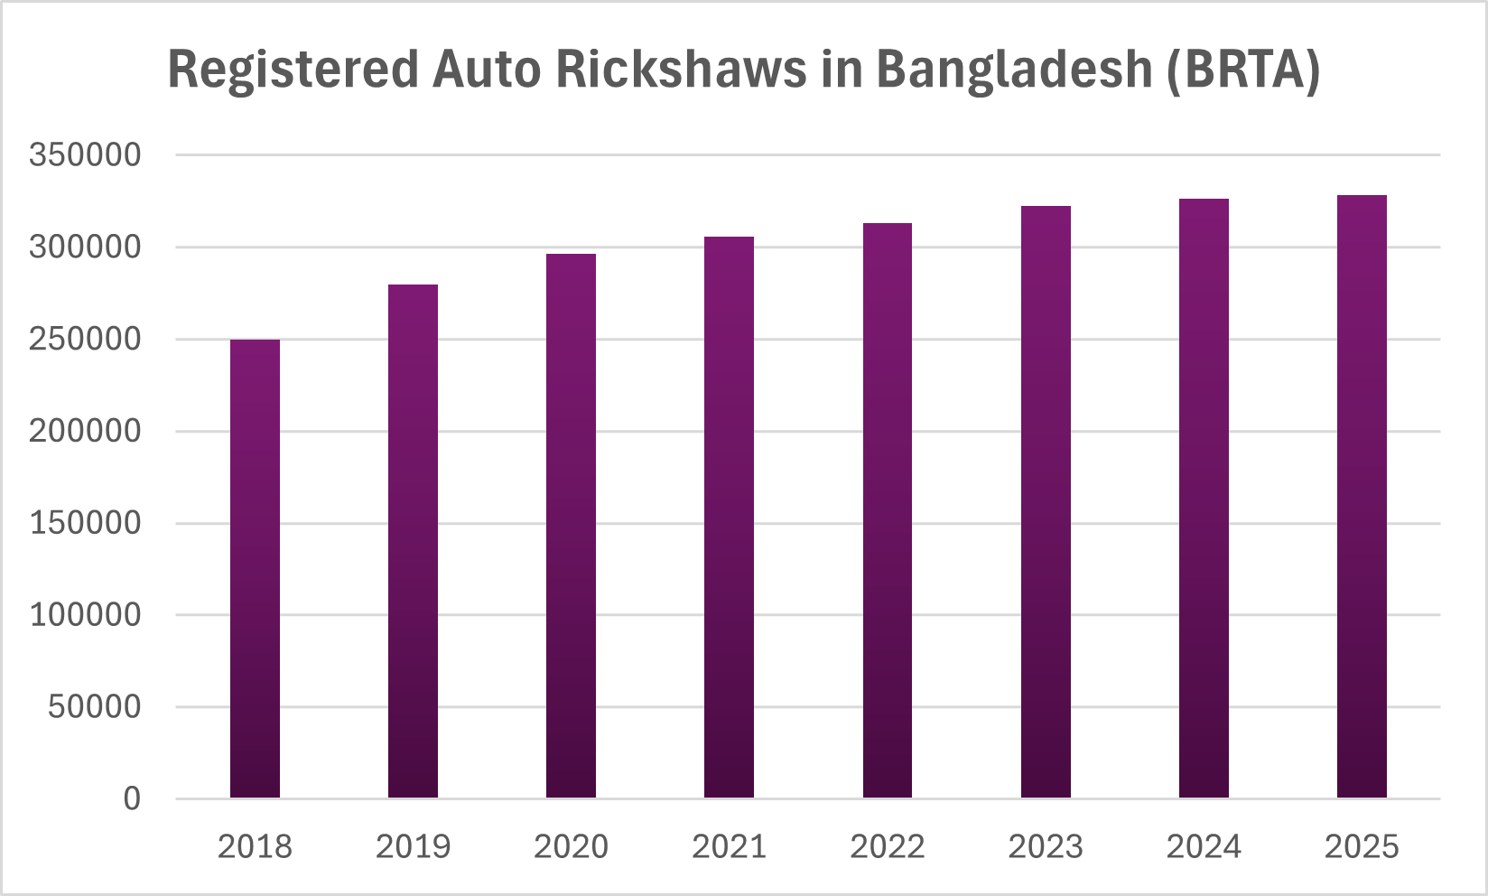

Source: <https://brta.gov.bd/sites/default/files/files/brta.portal.gov.bd/page/6d849ccb_09aa_4fbe_aef2_3d254a2a0cd1/2025-10-08-05-56-bee23f635b80a0d1bacb58d220be684e.pdf>

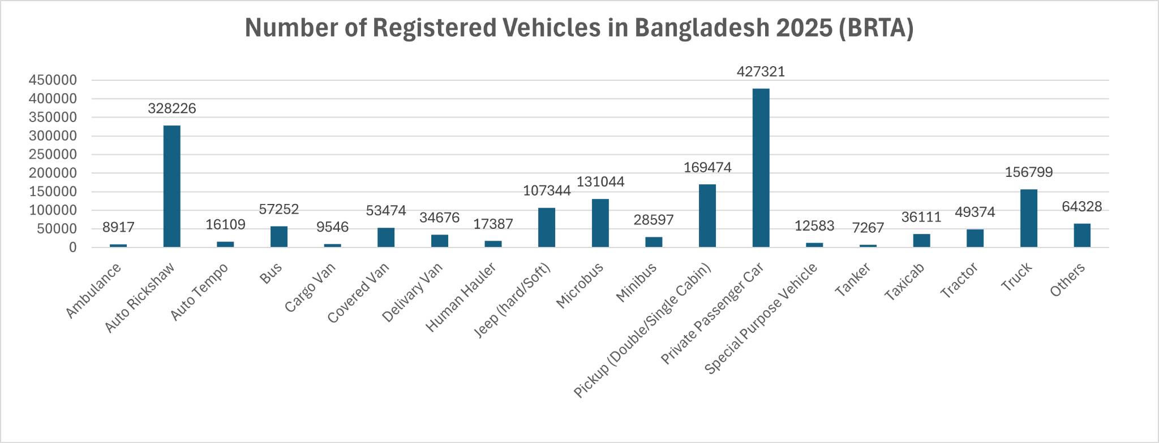

Source: <https://brta.gov.bd/sites/default/files/files/brta.portal.gov.bd/page/6d849ccb_09aa_4fbe_aef2_3d254a2a0cd1/2025-10-08-05-56-bee23f635b80a0d1bacb58d220be684e.pdf>

**Socio-economic roles**

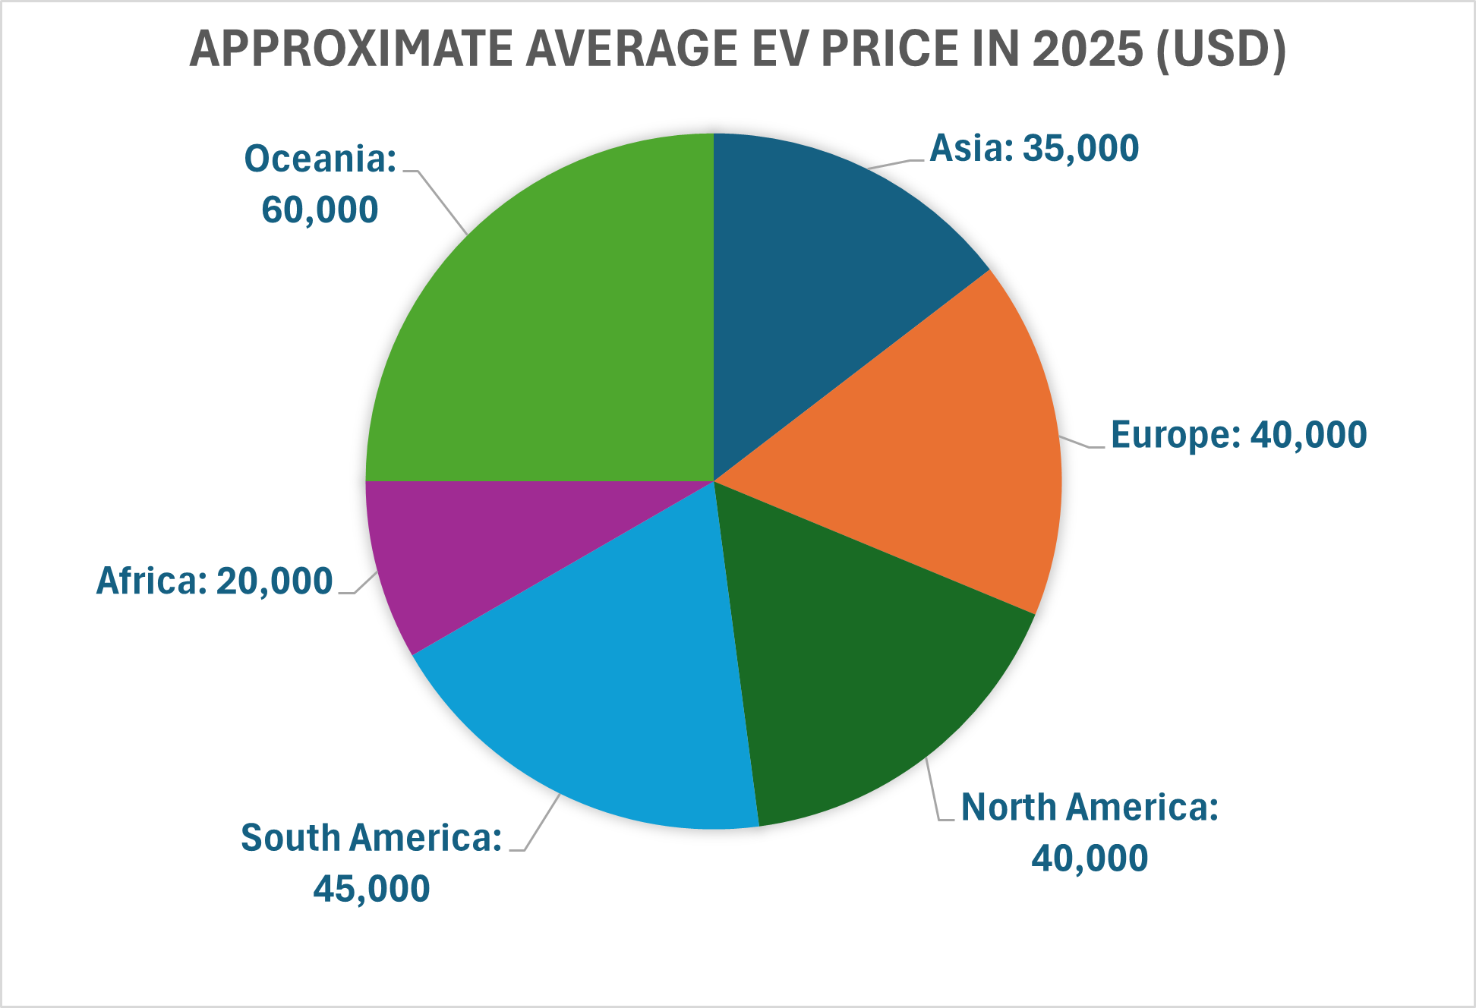

*Source:*

[*https://www.ev24.africa/how-much-does-an-electric-car-cost-in-africa/*](https://www.ev24.africa/how-much-does-an-electric-car-cost-in-africa/)

[*https://www.iea.org/reports/global-ev-outlook-2025/executive-summary*](https://www.iea.org/reports/global-ev-outlook-2025/executive-summary)

[*https://www.sci-tech-today.com/stats/electric-vehicle-statistics-updated/*](https://www.sci-tech-today.com/stats/electric-vehicle-statistics-updated/)

[*https://www.transportenvironment.org/articles/whats-wrong-with-electric-car-prices*](https://www.transportenvironment.org/articles/whats-wrong-with-electric-car-prices)

[*https://mobilityforesights.com/product/europe-electric-vehicle-market*](https://mobilityforesights.com/product/europe-electric-vehicle-market)

[*https://thedriven.io/2025/05/15/global-ev-sales-to-hit-20-million-in-2025-as-prices-hit-parity-in-key-markets/*](https://thedriven.io/2025/05/15/global-ev-sales-to-hit-20-million-in-2025-as-prices-hit-parity-in-key-markets/)

*Environmental benefits*

*Current statistics and key stakeholders*

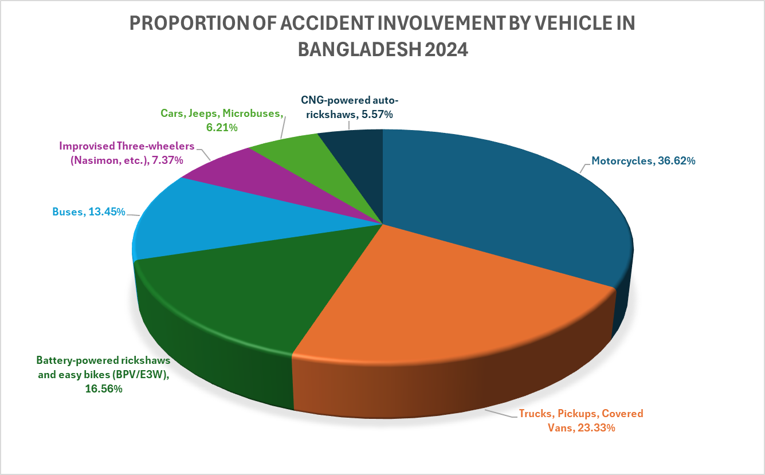

Fig: Proportion of accidents by vehicle in Bangladesh 2024-25 .

The chart “Proportion of Accidents by Vehicle in Bangladesh (2024–25)” represents how different vehicles are involved with road accidents, based on the Passenger Welfare Association of Bangladesh (PWAB) report (January 2025). In 2024, almost 8,543 people lost their lives in road accidents. Motorcycles topped the list with 36.62% of total accidents, showing the risks from their rapid increase and unsafe driving. On the other hand CNG auto-rickshaws (5.57%) and cars/microbuses (6.21%) had the lowest accident rates. A key point is the rise of battery-powered rickshaws and e-bikes (16.56%), which now cause a large share of accidents despite being low-speed vehicles. The expansion of battery-powered vehicles (BPVs)—while environmentally friendly and cost-effective—raises concerns about driver training, load management, and road safety. Overall, the chart highlights both the positive trend towards electric mobility and the urgent need for structural policy and safety integration to ensure sustainable electric vehicle growth in Bangladesh.

**Source/Ref:**

[New Age | 8,543 people killed in road accidents in Bangladesh in 2024: report](https://www.newagebd.net/post/country/254496/8543-people-killed-in-road-accidents-in-bangladesh-in-2024-report)

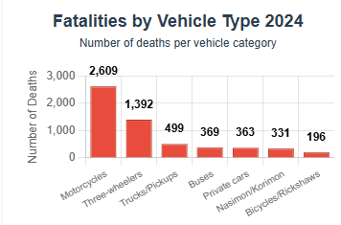

Fig: Number of deaths per vehicle category.

According to the report of the Road Safety Foundation (January 2025), this chart highlights a clear picture of the involvements of different vehicles in Bangladesh road accidents. In 2024, 12,019 people were injured and 7,294 were killed in 6,927 road accidents. The highest number of fatalities occurred by motorcycles (35.76%). It shows the growth of usage and vulnerability because of high speeds and poor safety measures. Three-wheeled vehicles, including battery-powered rickshaws and easy bikes, came in second with 19.08% of deaths. It highlights that even low-speed vehicles can cause serious damage in mixed traffic situations. Heavy vehicles such as trucks, pickups (6.84%), and buses (5.05%) are often associated with road congestion and reckless driving. At the lower end, bicycles and manual rickshaws (2.68%) showed lower fatality rates. But they were still common among low-income commuters. Overall, the chart represents a serious road safety crisis, especially with the rise of electric and battery-powered vehicles (BPVs) in urban and semi-urban areas. As Bangladesh moves towards the adoption of electric vehicles to reduce fatalities and increase sustainable mobility, it is crucial to ensure driver training, safe road infrastructure, and regulation.

**Source/Ref:**

Road Safety Foundation (January 2025)

Bangladesh witnessed 7,294 deaths and 12,019 injuries from 6,927 road accidents in 2024.

SRC: [Bangladesh witnessed 7,294 road accident deaths in 2024: Report | Prothom Alo](https://en.prothomalo.com/bangladesh/m4kzejfpvx)

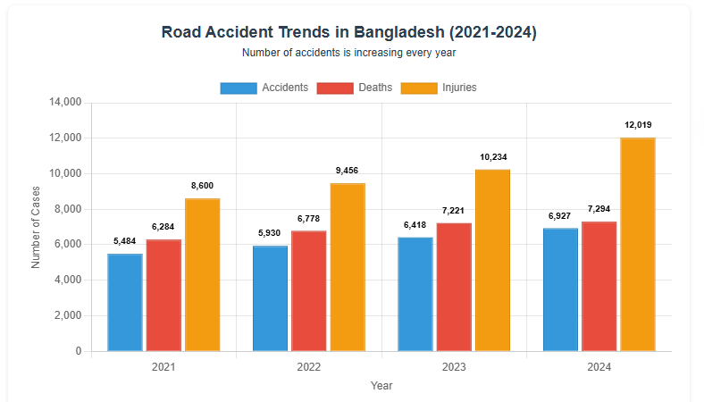

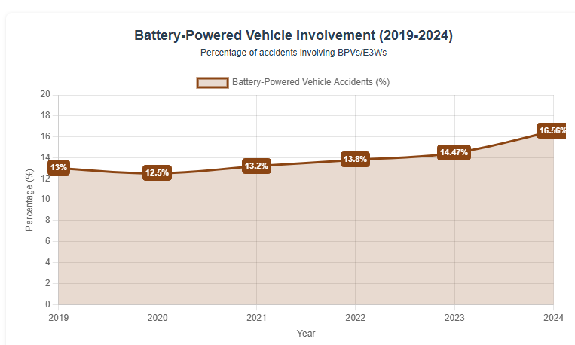

Fig: “%” of accidents involving BPVs / E3Ws

The chart “Battery-Powered Vehicle Involvement (2019–2024)” shows the gradual rise in road accidents involving battery-powered vehicles (BPVs) and electric three-wheelers (E3Ws) in Bangladesh. Over six years, the percentage increased from 13% in 2019 to 16.56% in 2024, marking a steady upward trend. This rise reflects the rapid growth in the number of easy bikes and battery-run rickshaws, especially in urban and semi-urban areas where these vehicles serve as low-cost public transport. However, the increase in accident rates highlights major safety and regulatory challenges—such as lack of licensing, improper driver training, and inadequate traffic management. While BPVs contribute positively to reduced emissions and affordable mobility, their growing involvement in accidents raises concerns about infrastructure readiness and enforcement of safety standards. The trend emphasizes the urgent need for policy intervention, route regulation, and technical standardization to ensure that the shift toward electric mobility remains sustainable and safe for Bangladesh’s transportation ecosystem.

**Source/Ref:**

Electric Vehicles/Battery-Powered Vehicles (EVs/BPVs/E3Ws) Data:

# 2024 Data: [New Age | 8,543 people killed in road accidents in Bangladesh in 2024: report](https://www.newagebd.net/post/country/254496/8543-people-killed-in-road-accidents-in-bangladesh-in-2024-report)

- Battery-powered rickshaws and easy-bikes were involved in 16.56% of crashes in 2024

# 2023 Data: [Road accidents claim 7,902 lives in 2023 | The Business Standard](https://www.tbsnews.net/bangladesh/transport/road-accidents-claim-7902-lives-2023-774622)

- Battery-operated rickshaws and easy-bikes accounted for 14.47% of vehicles involved in accidents in 2023

# Historical Context: [Affordable Electric Three-Wheeler in Bangladesh: Prospects, Challenges, and Sustainable Solutions](https://www.mdpi.com/2071-1050/15/1/149)

- In 2019, 8% of fatal accidents in Dhaka district were caused by E3Ws, which was 13% for the whole country

- Approximately 1 million electric three-wheelers were operating in Bangladesh, projected to grow to 2.5 million by 2025

**5. Opportunities of Battery-Powered Vehicles (Nehal)**

*Environmental Benefits*

These battery-powered vehicles produce negligible carbon emissions compared with diesel-powered vehicles, which is contributing to improving urban air quality for better public health in dense cities.

The overall climate benefit of electric vehicles mostly depends on the country’s electricity mix. As most of our grid electricity still comes from fossil fuels. But electric drivetrains are more energy-efficient, and centralized power generation is often cleaner than the many small fuel engines used in traditional vehicles. As a result, the total lifecycle CO₂ emissions per passenger-kilometer for battery-powered vehicles are generally lower than those of conventional diesel-powered vehicles, according to published studies. When battery-powered vehicle charging is combined with renewable sources such as solar power, the environmental benefits increase significantly. Recent models also show that widespread adoption of battery-powered vehicles can noticeably reduce CO₂ emissions and particulate pollution in urban areas.

But the growth of electric vehicles has brought serious battery management challenges. Improper battery disposal, informal recycling, and unsafe charging of lead-acid batteries can cause environmental and health risks. Sustainable EV adoption in Bangladesh will require proper battery recycling systems, safe collection mechanisms, and standardized regulations for battery use. That includes a shift toward sealed lithium batteries or properly managed lead-acid systems. Several studies have stated that, poor battery disposal and unregulated charging are key sustainability issues

Battery-powered vehicles significantly reduce noise pollution, which improves comfort and livability in crowded urban and residential areas. Many researchers say this quieter operation is recognized as an additional benefit, alongside better air quality.

*Economic Opportunities*

*Energy Sector Integration*

*Urban Transport Efficiency*

*Technological Innovation*

**6. Challenges and Barriers (Rakesh Biswas)**

***6.1Energy & Infrastructure***

**Grid Capacity and Power Supply Concerns**

Bangladesh's electric vehicle ecosystem faces significant challenges of energy infrastructure. The country's electricity grid is already under pressure from existing demand. Again, it is facing additional pressure due to EV charging requirements. Electric three-wheelers consume about 5% of Bangladesh's total electricity consumption. Most of which comes from fossil fuel sources such as natural gas, potentially neglecting some of the environmental benefits of e-mobility. It means that EVs are only as environmentally friendly as the source of power generation.

The current erratic power supply in Bangladesh is a major hurdle for EV adoption. Frequent load shedding creates serious reliability concerns for owners who depend on a steady flow of electricity to charge their vehicles. These outages don't just inconvenience users; they also erode confidence in electric vehicle technology as a practical and dependable transport solution.

**Charging Infrastructure Deficiency**

As of 2024, the country only has 14 government-approved stations with a total capacity of 282 kW. Worse, most are solar-powered, which means you're looking at extremely long charge times—totally unusable for commercial vehicles that need a quick turnaround. These stations are tightly clustered in Dhaka and other big cities. They can be located at places like Audi Bangladesh in Tejgaon and the Sumatra Filling Station in Cantonment, with others scattered in Comilla, Narayanganj, Chittagong, Gazipur, and Jessore. The required charging time highlights additional operational or functional complications. For example, battery-powered rickshaws and easy bikes, require a notably long charging duration of six to eight hours for a full cycle. This results in a daily expenditure estimated between 120 and 150 BDT, with these costs steadily rising annually due to increasing electricity tariffs. While home charging is an alternative solution, it necessitates the installation of specialized high-voltage electrical connections. The consumer is fully responsible for bearing the entirety of these associated installation costs. Moreover, the electricity utilized for this charging is levied at the commercial rate, which is significantly higher than the standard residential tariff.

**Renewable Energy Integration Limitations**

In 2024, Bangladesh's renewable energy capacity showed strong growth, increasing by 42.7% and adding about 331 MW of power to the main grid. However, this progress is at risk because there are very few investment projects ready for 2025-2026. This could limit growth in the future. The country has a big goal to triple its renewable energy capacity by 2030, which means it needs to add 3,000 megawatts of new projects.  
Unfortunately, only about 500 MW of these projects are currently in the advanced stages of construction. This large difference between the country’s goal and the current pace of development severely restricts the growth of a genuinely environmentally friendly EV ecosystem.

***6.2Regulatory***

**Absence of Formal Recognition and Standardization**

One of the main regulatory issues is that electric three-wheelers, the most common type of EV in Bangladesh with 3-4 million vehicles, which aren't officially recognized. The National Electric Vehicle policy and the regulations of the Bangladesh Road Transport Authority (BRTA) do not cover them. Due to this- the sector operates informally without proper oversight or quality control. Research shows common issues like bad brakes, suspension problems, and structural weaknesses that can cause rollovers. Since there are no required safety certifications, these unsafe vehicles continue to operate on public roads, putting drivers and others at risk.

**Policy Fragmentation and Coordination Gaps**

The clean energy sector is facing issues due to a lack of coordination between government organizations and private companies, and many people involved don't have the necessary skills. Many regulatory bodies- such as SREDA, BRTA, Bangladesh Energy Regulatory Commission, and the Ministry of Power, Energy and Mineral Resources, are in charge of different parts of the electric vehicle industry. However, these bodies don't coordinate well. This lack of coordination leads to bureaucratic inefficiencies and conflicting requirements, which hinders the industry's progress.

***6.3Battery & Waste Management***

**Lead-Acid Battery Dominance and Associated Hazards**

Each easy bike battery set is incredibly heavy, holding about 125 kg of lead. That is 15 times more lead than what is found in a standard car battery. Since these lead-acid batteries only last 8 to 11 months, they generate a staggering amount of waste: over 167,000 metric tons of lead every year in Bangladesh. This rapid need to replace batteries creates a huge, continuous waste management problem. Battery manufacturing and recycling are handled by both registered ("formal") and unregistered ("informal") businesses. The informal groups often recover lead using simple, coal-based open-pit furnaces that have no equipment to control pollution. While formal recycling facilities are much better, losing only 1,134$ tons of lead, informal recycling is responsible for an enormous loss of $6,924$ tons of lead in 2021 alone. This means 86% of all lead loss comes from informal recycling.

**Environmental and Health Impacts**

Since most lead waste is recycled in those informal open-pit furnaces, it causes serious lead pollution. This contamination poisons the workers directly and the people living nearby. Shockingly, two out of every three children in Bangladesh now have dangerously high levels of lead in their blood. This kind of poisoning leads to problems like IQ loss, worse educational outcomes, lower future earnings, and severe heart and kidney diseases. Studies show that over 20\% of the population lives within 5 km of an informal smelting site, and people living there see a 6-percentage point rise in terminated pregnancies.

Beyond the direct poisoning, the informal making of EV batteries is a major cause of problems like land use damage, global warming, air pollution (fine particulate matter), and acid rain. Global warming and air pollution each make up about 40% of the total health risks caused by this industry. Workers in the informal sector face an alarming risk of developing toxic diseases. The majority of these non-cancer risks—90.8%—come from lead entering the body through the mouth.

**Regulatory Vacuum in Battery Management**

There is a major gap in the rules. While the national hazardous e-waste policy covers household batteries, it completely ignores used lead-acid batteries from electric three-wheelers. Because the vehicle and battery sectors are mostly informal and unregulated, the government loses huge amounts of money in taxes. Only 30% of lead-acid battery recycling is formal, which results in tax revenue losses of about US$91 million every year. Currently, there are no battery tagging systems to check quality or tracking technology to monitor how batteries are used. This makes proper end-of-life disposal almost impossible. Without a clear national list of operators to ensure accountability, and without formal rules for recycling, the entire sector will continue to cause environmental damage and public health problems.

**Transition Challenges to Lithium-Ion Technology**

Lithium-ion batteries (Li-ion) are much better: they hold more energy and last much longer (about 4,000 cycles versus 300-600 for lead-acid). However, their significantly higher initial cost stops people from adopting them. Li-ion prices range from 56,000 to 200,000 BDT, while lead-acid costs just 12,000-23,000 BDT. Meanwhile, the short lifespan of current easy bike batteries (costing over 72,000 BDT but lasting only 8 to 11 months) pushes up operating costs and harms the millions of drivers and owners who rely on these vehicles for their income. Finally, the system for recycling Li-ion batteries is also not ready in Bangladesh. Information about recycling centers and how to process the batteries is very limited.

***6.4Economic***

**High Upfront Costs and Affordability Barriers**

While EVs save money in the long run on running costs, the initial purchase price is simply too high for most Bangladeshi buyers when compared to standard petrol or diesel cars.

For four-wheeled vehicles, the issue is excessive import taxes and customs duties, which make EVs overpriced. Such as, EVs with large motors (over 175kW) are taxed as heavily as if they had a massive 3,500cc engine, leading to taxes as high as 200,000 BDT. Furthermore, unlike its neighbors, Bangladesh does not offer any subsidies to encourage the local manufacturing of electric vehicles.

The situation remains difficult even for more affordable three-wheelers. The cost of replacing batteries severely impacts the total expense of owning the vehicle. A new set of easy bike batteries costs 70,000-90,000 BDT but only lasts 1 to 1.5 years. These frequent, high replacement costs put a huge financial strain on drivers and owners who often operate with very little profit.

**Limited Incentive Structures**

The government has attempted to encourage EV adoption through tax breaks and import duty exemptions, but these measures don't quite match up to what other countries are doing. For example, India's FAME-II program offers significant subsidies, like up to 1.5 lakh BDT for four-wheeled vehicles and up to 40% of the purchase price for two-wheeled vehicles.

The environmental surcharge which is proposed on second vehicles, based on power rating, could also create an issue. This fee might actually discourage people from buying electric cars as a second vehicle. If the government doesn't remove this surcharge for EVs, the policy could unintentionally slow down the shift from gasoline cars to electric alternatives, which is what it's trying to promote.

**Market Development Constraints**

The Electric vehicles market is very sensitive to price, and high initial costs make it difficult for many to afford EVs. Also, there aren't many EV models available, which limits choices and keeps prices from becoming more competitive. Because Bangladesh relies on imports, costs are higher, making EVs less accessible, especially for those in rural or smaller urban areas.

***6.5Social & Safety Concerns***

**Accident Rates and Traffic Safety**

Electric three-wheelers—of which there are an estimated 3 to 4 million—dominate Bangladesh's electric vehicle sector. However, the biggest challenge they pose is the high risk of accidents. The involvement of battery-powered rickshaws and easy bikes in road crashes is steadily increasing, reaching 16.56% of all accidents in 2024, up from 13% in 2019. This upward trend reflects the rapid and uncontrolled spread of these vehicles without any corresponding upgrades in safety rules or proper operator training.

The fatality data is also alarming. In 2024, three-wheeled vehicles accounted for 19.08% of road traffic deaths, making them the second-leading cause of fatalities, only behind motorcycles (at 35.76%). The total number of road traffic fatalities in 2024 was 8,543, with battery-powered vehicles making up a significant and growing portion of these deaths.

**Contributing Factors to Safety Concerns**

One significant factor that raises accident risk is that many drivers are underage and haven't received proper training or licensing, leading to hazardous conditions on the road. Moreover, many drivers don't understand traffic rules or defensive driving techniques, which may lead to unpredictable behavior on the roads. Speed management is another issue, as slow-moving battery-powered vehicles mix with faster traffic on major roads without designated lanes or speed limits.

Mechanical problems are a big part of the safety issue. When things like the brakes don't work well or the suspension is worn out, the vehicle is much more likely to flip over, or rollover. This risk is even higher if the vehicle is carrying too much weight. Since there are no required vehicle inspections, these broken-down cars and trucks keep being used. That means everyone on the road—passengers and others—is facing greater danger.

**Public Awareness and Knowledge Gaps**

One remarkable thing is that most of the people are not aware enough about the benefits of EVs. Potential buyers often have incorrect ideas about their performance, reliability, and maintenance needs. Even current EV users often don't know enough about how to handle batteries properly, charge them safely, and perform maintenance.

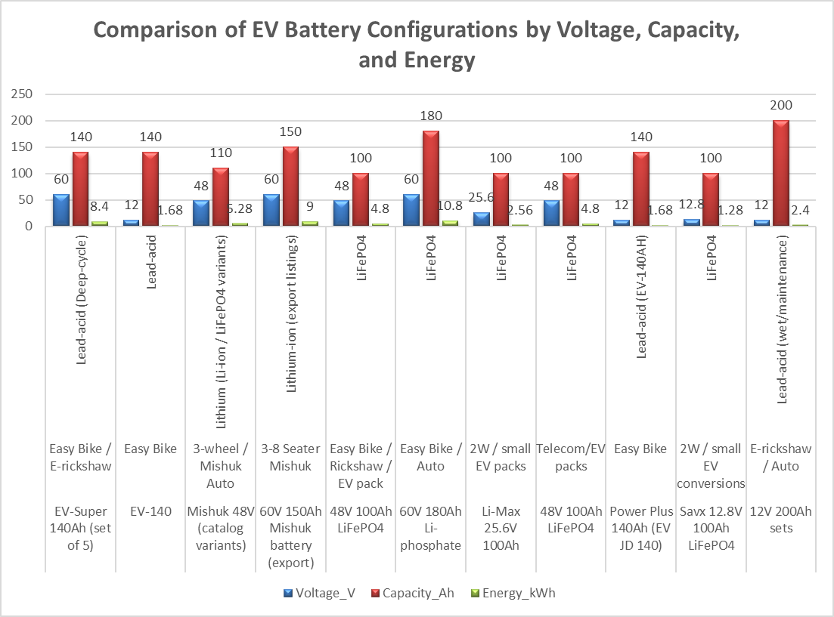

Fig: EV Battery Specs & Trends – BD 2025

Electric Vehicle Battery Configuration—The figure represents a diverse scenario based on voltage, power, chemistry, and cost. Lead-acid batteries are prioritized and remain in the first-layered E-rickshaw for their affordable price, where the price range starts from 12,000 BDT. Yet they provide limited energy (1.68 kWh) and a short lifespan (300-600 cycles). On the other hand, Li-based batteries, especially LiFePO,4 gained attraction for high energy density and long life cycle (~4000 cycles). Although the higher price can be reached at 200,000 BDT. 12V to 60V energy output ranging from 1.28 kWh to 10.8 kWh offered by HyperEnergyBD's 60V 180Ah pack. The 48V 110Ah Li-battery stands as a balanced alternative to electric three-wheelers (E3Ws)/mishuks, which combines sustainability and a moderate price with 5.28 kWh of energy. Moreover, Savx, Liwatt, and Sako brands are launching specialized LiFePO4 packs made for small electric vehicles and two-wheelers. It is expanding the range of applications beyond typical rickshaws. Finally, the market reflects the gradual changes towards Li-technology driven by performance, longevity, and growing EV demand.

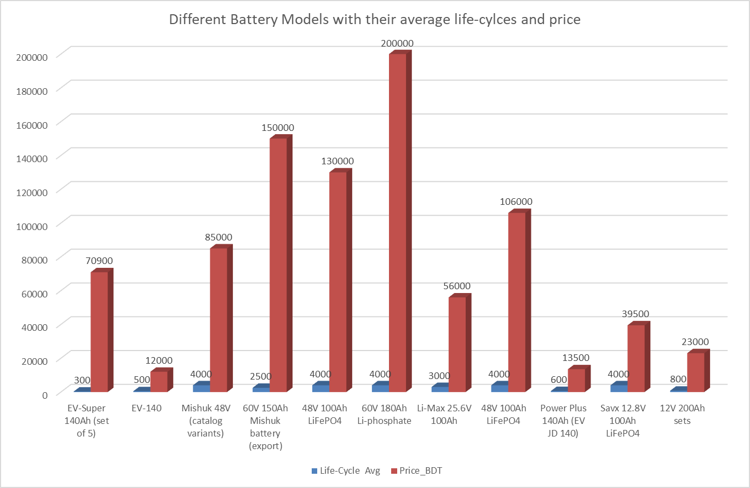

Figure: EV Battery Models – Life-Cycle vs. Price Comparison

The figure titled "Different Battery Models with their Average Life-Cycles and Price" presents a comparative analysis of electric vehicle battery alternates, and also it highlights the key trade-offs between costs and longevity. On the top, the 60V 180Ah LiFePO4 battery of HeperEnergyBD has a lifespan of 4000 life cycles and a price of 200,000 BDT, which makes it ideal for high-performance EVs. Same as Savx, Liwatt and GreenTiger offer LiFePO4 variants with 4000-cycle durability and prices ranging from 85,000 to 130,000 BDT. They balance longevity and affordability. In contrast, the Hamco EV-140 and Power Plus 140Ah lead-acid models are the most budget-friendly. which are priced around 12,000 to 13,500 BDT, but they offer only 500-600 cycles. They are suitable for short-term use. The generic 12V 200Ah lead acid set offers a moderate price at 23,000 BDT with 800 cycles. Export-grade lithium options like Alibaba's 60V 150Ah pack offer 2500 cycles at 150,000 BDT, which reflects international standards. It is remarkable that the Saco Li-Max 25.6V 100Ah delivers 3000 cycles for just 56,000 BDT. This makes it an affordable lithium choice for small EVs. In fact, the figure represents a clear trend: LiFePO4 batteries dominate in terms of durability, while lead-acid remains the low-cost option. Mid-range Li-battery models offer the best balance for the growing demands of electric vehicle demand.

**Source/Ref :**

|  |
| --- |
| [https://kotharakhi.com/product-tag/navana-easy-bike-battery-price-in-bangladesh/;%20https:/navana-battery.com/electric-vehicle-ev-easy-bike-battery/https://kotharakhi.com/product/navana-ev-140ah-battery-price-in-bangladesh/](https://kotharakhi.com/product-tag/navana-easy-bike-battery-price-in-bangladesh/;%20https:/navana-battery.com/electric-vehicle-ev-easy-bike-battery/https:/kotharakhi.com/product/navana-ev-140ah-battery-price-in-bangladesh/) |
| <https://www.bdstall.com/details/hamko-ev-140-140ah-easy-bike-battery-77355/> |
| <https://www.alibaba.com/product-detail/Low-Price-5-8-Seater-Mishuk_1601440331513.html> |
| <https://www.alibaba.com/product-detail/5-8-Seater-Mishuk-Auto-Rickshaw_1601439908761.html> |
| <https://bme.com.bd/savx-48v-100ah-lithium-battery> |
| <https://www.hyperenergybd.com/product/60v-180ah-lithium-phosphate-battery-for-easy-bike-auto/> |
| <https://ipshatbazar.com/products/809228> |
| <https://solarsystembd.com/shop/battery/liwatt-lithium-ion-battery-48v-100-ah-telecom/> |
| <https://kotharakhi.com/product/power-plus-140-ah-easy-bike-battery-price-in-bangladesh/> |
| <https://bme.com.bd/savx-12v-100ah-lifep04-lithium-battery> |
| <https://kotharakhi.com/product/voltex-200ah-ips-battery-price-in-bangladesh/> |

**Table 5: Framework for Managing and Reducing Challenges of Battery-Powered Electric Vehicles in Bangladesh**

|  |  |  |  |  |  |
| --- | --- | --- | --- | --- | --- |
|  |  |  |  |  |  |
| **Safety and Structural Management** | **Traffic and Congestion Control** | **Driver Licensing and Age Verification** | **Electrical Grid Integration and Load Management** | **Battery Quality and Lifecycle Management** | **License Tracking and Vehicle Registration** |
| •Safety standards, vehicle inspection •Braking issues, suspension faults •Structural integrity, rollover risk | •Traffic coordination,lane zoning •Speed management,slow vehicle flow •Stopping zones, traffic flow | •Licensing requirements, digital verification •Underage drivers, enforcement gaps •Verification systems, licensing gaps. | •Controlled charging, off-peak usage. •Peak load shifts, grid distortion. •Harmonics, power quality. | •Battery health, lifecycle, disposal. •Short lifespan, cost impact. •Lead-acid contamination. | •Centralized database, registration, monitoring. •Unregistered vehicles, oversight challenges. •Substandard vehicle tracking |

The table highlights six key indicator and management areas needed to manage the rapid growth of Electric Vehicles (EVs) in Bangladesh. Under safety and structural management, the importance is on implementing uniform safety standards. It addresses mechanical defects such as poor braking and rollover hazards which cause fatal accidents. Traffic and congestion control highlights the need for specific lane and speed protocols to prevent traffic congestions occurred by slow-moving Electric Vehicles. Driver licensing, strict protocols and age verification can make stops or slowdown of premature or underage driver expansions. Integration of electric grid focuses on the uncontrolled charging risk. Battery quality and life span management can address environmental risks. At last, finally the government should focus on license tracking, vehicle registration, low quality vehicle identification, real time observation. Along with these categories reflect the secure, need for coordinated policy reforming, efficient and sustainable EV adoption.

**7. Regional Perspective (Nehal)**

In cities like Jashore of Bangladesh these battery powered vehicles operate mainly in small distances typically ranging 3-10 km. As a large number of the population do not possess owned vehicles. These battery powered vehicles meet the intermediate transport demands.They compete with local diesel powered vehicles like Mahindra, cycle, local bus, mini buses for short to medium trips.

As these battery powered vehicles reduce human labour compared to cycle and traditional rickshaws and their excessive availability making them most acceptable transportation for short to medium trips for urban cities like Jashore.

***Purchase cost:***

Typical retail prices in Bangladesh for easy-bikes or small electric three-wheelers range depending on model but consumer listings show affordable locally-priced models in the 1,15,000 to 2,00,000 taka range for battery powered three wheelers and with more customized imported models costing more. These prices place battery powered vehicles below many motorized three-wheelers that operate locally. Here the table shows the retail price of different locally operated battery powered vehicles:

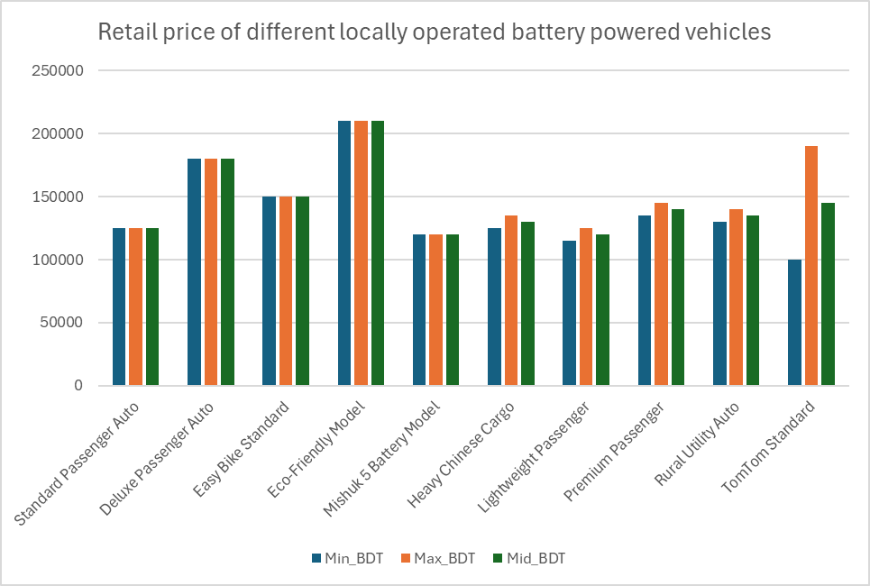

***Operating cost:***

The main operational cost for these battery powered vehicles are electricity charging. This charging cost still remains compared to fuel. Our local findings show that the estimated daily charge cost is 40 taka to 150 taka varying different models. The table shows the summary of our local findings about their charging demand:

|  |  |  |
| --- | --- | --- |
| Vehicle type | Charging demand in new condition | Charging demand in old condition |
| Easy Bike | 8-9 Unit | 10-12 Unit |
| Battery Powered Rickshaw | 4-6 Unit | 5-6 Unit |
| Battery Powered E-Van | 4-6 Unit | 5-6 Unit |

Table: Daily charging demand of Table: Daily charging demand of different battery powered vehicles.

Another operation cost includes the battery. As the life cycle of these batteries are typically 1-1.5 years, the battery price also needs to be considered. The table shows the summary of our local findings about the battery prices:

|  |  |  |
| --- | --- | --- |
| Vehicle type | New Battery Price (BDT) | Used Battery Price (BDT) |
| Easy Bike | 70,000-90,000 | 30,000-40,000 |
| Battery Powered Rickshaw | 25,000-30,000 | 10,000-15,000 |
| Battery Powered E-Van | 25,000-30,000 | 10,000-15,000 |

Table: Battery price of different battery powered vehicles.

***Drivers Income:***

Studies found that drivers of these battery powered vehicles can earn typically 700 taka to 1000 tk per day. This is case dependent as the demand may vary everyday. But their daily average income tends to 850 taka which is very attractive relative to capital and operating cost.

***Time Cost:***

These battery powered vehicles are almost door-to-door service for the passengers or in some cases less than 1 Km distance from their home. So the waiting time for these vehicles are very less. The trip times for short trips are often lower than waiting plus walking to bus stops. Our local survey finds that the typical waiting time for local buses are 10 to 15 minutes which is more than most of the short trip times. So lower waiting time also makes these battery powered vehicles the preferred choice for the passengers.

***Public Cost:***

Battery powered vehicles are one of the cheapest and most available public transport that mostly covers the Jashore city area. There are several routes and stoppages of easy bikes. These routes and stoppages are not authorized or affirmed by the city corporation. They are gradually developed based on passenger demand. In Jashore city these easy bikes cover the highest area compared to other public transports. The stoppages are also very close which ensures the door-to-door service to passengers. The stoppages are mostly within 500 meter range. Even some stoppages are within walking distance.

The fare is mostly based on distances or demand. The table shows the fare structure of easy bikes in different routes of Jashore city:

|  |  |  |
| --- | --- | --- |
| Easy bike Route | Distance (Km) | Fare (BDT) |
| Palbari to Doratana | 2.8 | 10 |
| Palbari to New Market | 2.6 | 10 |
| Palbari to Monihar | 4.2 | 20 |
| Palbari to Chachra | 4.3 | 20 |
| Palbari to Churamonkathi | 4.9 | 15 |

Table: Fare structure of easy bikes in different routes of Jashore city

From the fare structure we can see the fare is roughly 3 to 4 taka per passenger-km which actually makes it favorable for local passengers.

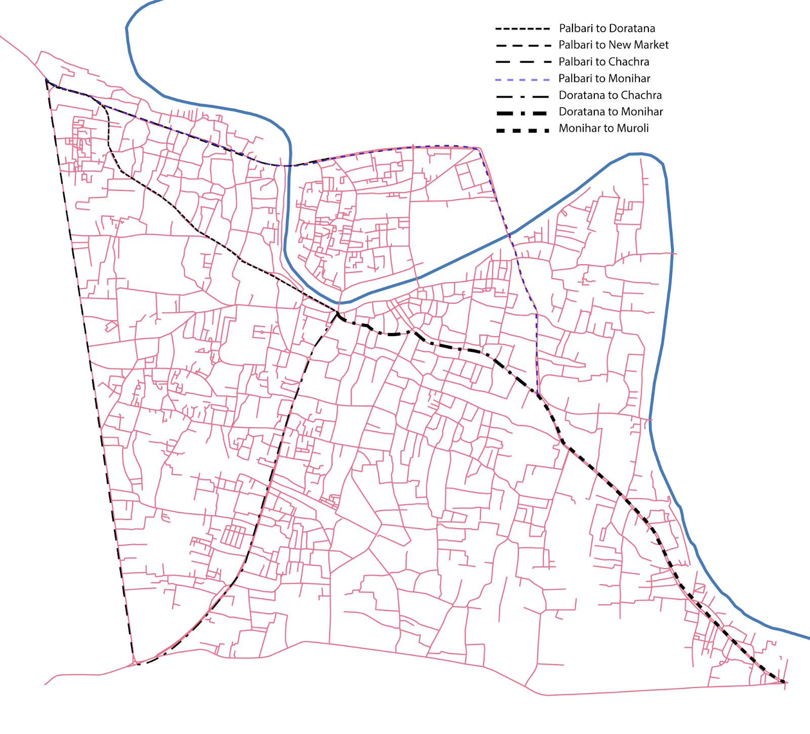

Figure: Easy bike routes of Jashore City

**8. Emerging Scopes and Future Directions (Nehal)**

**9. Challenges and Possible Solutions (Rakesh Biswas)**

Addressing the challenges of battery-powered vehicles in Bangladesh requires well-rounded solutions that involve many stakeholders, balancing the need to get these vehicles on the road quickly with the importance of safety, sustainability, and economic practicality.

**9.1 Energy Infrastructure Solutions**

**Grid Modernization and Load Management**

Bangladesh needs a plan to handle the growing electricity needs of electric vehicles (EVs) without straining the current power grid. This means using smart grid technology and finding better ways to manage how much electricity is used. It's also vital to use the power sector's current capacity as much as possible to reduce energy waste. Utility companies should also explore how to make future charging systems more environmentally friendly by incorporating solar power.

**Accelerated Charging Infrastructure Development**

To promote the growth of electric vehicle charging, SREDA and local power companies should work closely together. The government should aim high when setting goals for the number of charging stations, making sure to consider specific needs in cities, suburbs, and rural areas so that everyone has good access. The government can also work with private companies to build charging stations more quickly. By sharing the investment risks and using the private sector's efficiency, infrastructure development can be accelerated. The Bangladesh Energy Regulatory Commission should finalize the service charge structures to ensure that charging stations are profitable for operators while remaining affordable for consumers.

Charging corridors along highways should be prioritized to enable long-distance travel and reduce worries about running out of charge. Solar-powered charging stations are particularly promising for Bangladesh, using the country's abundant solar resources while reducing dependence on the grid and consumption of fossil fuels.

**9.2 Regulatory Framework Solutions**

**Formalization and Official Recognition**

Stakeholder workshops have resulted in eight policy recommendations, including officially regulating the electric three-wheeler sector, implementing battery tagging systems to ensure manufacturing quality, and establishing tracking technology to monitor batteries and manage their end-of-life. The Bangladesh Road Transport Authority (BRTA) should officially acknowledge three-wheelers, which would allow the Bangladesh Standards and Testing Institution (BSTI) to monitor the vehicles and their batteries. This would enable vehicle registration and battery tracking. Also, a temporary registration initiative should be introduced, allowing current three-wheeler operators to register without facing large fines. After this initiative, the government should ensure that all vehicles are registered and that those who aren't are held accountable.

**Safety Standards and Vehicle Certification**

Comprehensive safety standards that cover structural integrity, braking systems, suspension quality, and electrical safety must be developed and enforced. Programs that require vehicles to be inspected, similar to those for regular cars, should be implemented to assess whether vehicles meet safety standards before they are registered, and regularly after that. Standardization protocols should be based on international best practices while also considering the specific conditions in Bangladesh. The highest levels of regulations should adhere to international protocols ratified by Bangladesh concerning the harmonization of motor vehicles as adopted by the United Nations.

**Licensing and Training Requirements**

A detailed licensing system must be created just for battery-powered vehicle drivers. This system should involve a knowledge test (written) and a skills test (practical driving). We should also use national IDs to check ages and keep children from driving these vehicles. Mandatory training programs should teach drivers about vehicle operation, road rules, safe driving (defensive techniques), battery risks, and emergency steps. By working with manufacturers and operators, we can build training facilities that offer high-quality lessons for everyone. The licensing should be tiered—meaning more rigorous standards are needed for drivers who use these vehicles for commercial use or carrying passengers.

**9.3 Battery Management and Circular Economy Solutions**

To properly manage batteries and establish a circular economy for battery-powered vehicles in Bangladesh, it's essential to shift towards better-quality batteries. This can be achieved through new business approaches and microfinance options that encourage efficient battery return and recycling within the formal sector. "Battery-as-a-service" models can also help lower initial expenses while ensuring professional battery management and promoting safe disposal practices. Establishing formal recycling procedures, licensing and regulating recycling facilities, and implementing extended producer responsibility programs are crucial for creating a sustainable battery ecosystem. Moreover, integrating collection networks with vehicle service centers and charging stations, as well as using deposit-refund systems, can make it easier for users to return batteries and encourage responsible end-of-life management.

**9.4 Economic and Financial Solutions**

We need smarter incentives to make electric vehicles (EVs) truly popular in Bangladesh. So the government should consider reducing import taxes for a while to encourage more people to buy EVs. They should also look at giving tax breaks to EV owners, similar to the system used in India. Waiving the fee for a second vehicle—if that second vehicle is electric—could also make it easier for people to switch from gas cars to EVs. Taxing vehicles differently based on how much they pollute could also make a difference, giving cleaner vehicles a price advantage. Taxing high-emission vehicles heavily while keeping taxes low on zero-emission EVs shifts the market towards greener choices without needing a lot of direct financial support. Giving tax breaks for ten years to companies that invest in building and putting together energy-efficient vehicles can attract manufacturers, creating jobs and reducing the need to import everything. Supporting local companies that make parts for these vehicles helps build a strong supply chain and improve technical skills.

**10. Policy Recommendations (Nehal)**

Only a few aspects need to be addressed to promote the easy bike as a regular mode of sustainable transportation in Jashore. The following guidelines should be followed and adopted by the legislative and administrative authorities to improve the service of easy bike:

### **Easy Bike License and Driving License Provision**

The uncontrolled and unauthorized easy bikes are often responsible for creating traffic congestion and accidents in Jashore city. To control this, the number of easy bikes should be optimized, and there should be a proper system of legal provision. Therefore, the Jashore Pouroshova should provide licenses to authorize easy bikes. The Police should take the responsibility of monitoring and controlling the operation of unauthorized easy bikes and confiscating their operation. Along with a vehicle license, a driving license should also be provided to skilled and trained easy-bike drivers to decrease the rate of accidents. The Jashore Pouroshova or Ward Commission should define the age limit of the easy bike driver, as experience shows that young drivers tend to operate easy bikes at over speed, which causes accidents.

### **Development of Defined Stoppage**

The easy-bike stoppages are currently developed haphazardly throughout the city, including on major nodes or nearby commercial or business hubs, where passengers are easily available. There is no proper management of these stoppages, which is why easy bikes stop here and there on customer demand without any regulation, leading to traffic congestion and hindering the free flow of other vehicles. In order to control this, the Jashore Pouroshova should define easy bike stoppages by maintaining proper distance and proper location, where the movement of other vehicles will not be interrupted.

### **Operations, Regulations, and Management**

Easy bikes often operate in the internal streets of neighborhoods or on single-lane roads, which causes congestion and noise pollution. As there is no designated fare along these routes, drivers often get the opportunity to negotiate the fare with the passengers. Therefore, the Ward Commissioner should encourage the community not to use easy bikes in the internal streets and to use the designated fare set by the Regional Metropolitan Transportation Committee (RMTC) or a similar local body. The movement and other operations of easy bikes should be strictly controlled by the Police.

**11. Conclusion (Rakesh Biswas)**

Battery-powered vehicles present both a big opportunity and a tough challenge for Bangladesh as it strives for sustainable transportation. With millions of electric three-wheelers already in use, the country has shown there's a real need for affordable transportation options. However, this rapid growth has happened without the necessary regulations, infrastructure, and safety measures. Issues like inadequate charging stations, unsafe battery recycling, affordability problems, and safety concerns paint a picture of an industry at a critical point. The promise of electric vehicles to help the environment depends on fixing these underlying problems. The current way batteries are managed leads to health hazards and environmental damage, undermining the potential benefits of electric vehicles. To solve this problem, Bangladesh needs to adopt comprehensive solutions that create a circular economy.

Bangladesh can reach its goals for lowering emissions and using more electric vehicles by tackling key challenges. This means improving how different groups work together, building new skills, and carefully overseeing the process. The suggested solutions provide a clear path for turning these obstacles into opportunities. These solutions include upgrading the power grid, building more charging stations, improving battery quality, establishing recycling programs, adjusting financial incentives, and setting up safety standards. The economic side of things also needs careful consideration. While battery-powered three-wheelers have done well because they're affordable, making four-wheelers more accessible means tackling the cost problems through incentives. Policy changes should boost demand through tax reforms and lower fees, while ensuring charging stations are easily available for long-distance trips.